Minutes of the Parish Council Meeting held at Freeland Village Hall in the Newell Room at 19:30 on Monday 11th December 2023

The councillor chairing this meeting was Phil Holt

Members Present:

Cllr S Ainsley (SA), Cllr P Foster (PF), Cllr A Bird (AB), Cllr M Canning (MAC) Cllr R Crocker (RC), Cllr P Holt (PH), Cllr B Phillips (WP), Cllr V Baker (VB), Clerk Fay Friend (FF) and District Cllr L Arciszewska. Additionally 1 member of the public was in attendance.

1. To receive apologies for absence – Apologies have been received from District Cllr A Al-Yousuf and County Cllr L Walker.

2. To receive Declaration of Interest in agenda items – nothing to be added.

3. To approve minutes of the Parish Council meeting held on 13th November 2023– It was RESOLVED that the minutes were signed as a true record.

4. Public Participation session

No members of public wished to speak.

5. To discuss and agree any actions for urgent business

There were no matters of urgent business raised.

6. Update on progress from previous minutes.

Tree update- work has started across the parish to remove any dead or diseased trees and prune back branches causing issues to equipment. Work will continue over the next few months. RC supervising work.

7. Planning

(a) 1 new application.
Application number | Application address and detail | comments
23/02909/FUL | 1 Cuckoo Wood Caravan Park  Erection of a building for the garaging of fairground vehicles. | To confirm that the existing landscape screen is adequate.

(b) - To discuss the 20mph consultation proposal.

After some discussion concerning the extent of the proposed 20mph zone, it was agreed that the Parish Council will support the village when the consultation goes out to all residents (to be sent out by Oxford County Council early in 2024). Action: MAC to confirm this to Emile Rowe of OCC and remind them about adding reduction from 40mph to 30mph along the A4095 through the village.

8. To receive updates from District and County Councillors.

Lidia- The annual Waterways Day event was held recently, including presentations from Thames Water, EA and local catchment and environmental groups. All presentations from the speakers will be available shortly on the WODC website. Coronation Community Orchard Scheme has opened for Parish Councils and other community groups to apply for money to plan orchards on their land. A possible site for Freeland is the meadow at the front of Freeland Gate. Action: MAC to write to the residents, care of Mark O’Callaghan, to seek their view on this, and the implications in terms of maintenance costs.

9. To discuss and approve financial matters.

(a) To approve invoices for payment. - It was RESOLVED to pay the account presented, proposed by PF, seconded by WP and all in favour.

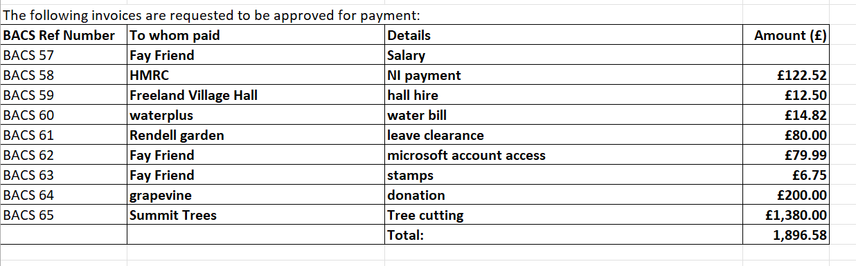

(b) To approve bank reconciliation. It was RESOLVED to approve the bank reconciliation. This was signed by WP.

(c) To review the financial reports. Reports were circulated and presented.

(d) To consider donation to the Grapevine – it was RESOLVED to give £200

(e) WP reminded Council of the need to carry out the annual review on the effectiveness of internal audit process and financial system before February meeting. SA and VB volunteered to carry this out in the new year. Action: SA and VB to arrange to meet with FF early in January.

10. Working Groups update

Community group: The working group is struggling to find enough support and had to cancel the Race Night on 2nd December due to poor ticket sales. As a result the group will not be able to organise the village event on June. It was agreed that the Parish Council does not have the capacity to take on the organisation for this. (One of the reasons for setting up working groups was to help spread the load out from Councillors.) FF to report back to the group.

Sustainable energy group: PF reported back on this group - there are some issues due to the chair of the Eynsham Net Zero group being on long term sick leave. This has lead to a temporary stalling of this aspect of the group’s work. However, members of the Freeland group are having success with rolling out the thermal imaging of village houses.

11. PARISH COUNCIL STANDING ITEMS:

(a) Play Areas/Playing Field/Play Equipment Book – toddler swing repair is due to start tomorrow. MAC to meet contractors on site at 8.00am.

(b) Village Maintenance and Highway Matters- the A4095 bus shelter Perspex has broken – need to organise repair. A quote is needed for pruning of Broadmarsh Lane laurel hedge to be trimmed. BP noted that part of this hedge has been replaced by fencing – most likely by residents of adjacent property.

(c) Tractor servicing- deferred to January meeting as awaiting quote.

(d) Little Free library trip hazard reported. Action: RC to investigate.

12. To receive reports from Councillors representing the Council on outside meetings RC, PF and MAC attended Parish Council Briefing on Botley West Solar Farm, organised by WODC. Presentation from this has been circulated. Parish Council to submit comments direct to developer by the 8th February, so meeting to be arranged for early January 2024 to draft a response for approval at meeting on 8th January.

13. To note the date of next meeting: 8th January 2024 in the Newell Room.

Meeting Closed at 21:10

